TABASURI DT SAVINGS AND CREDIT COOPERATIVE SOCIETY LTD.


TEXAS PLAZA BLOCK A 1ST FLOOR
Off Fidel Odinga Rd,
P.O.BOX 80862-80100,
MOMBASA

TENDER NO. TBS/RFQ/01/02/02/2026
REQUEST FOR QUOTATION: PROVISION OF EXTERNAL AUDIT SERVICES

REQUEST FOR QUOTATION: TBS/RFQ/01/02/02/2026
RFQ CLOSING DATE: 20TH FEBRUARY, 2026
RFQ CLOSING TIME: 1000HOURS
CONTACT PERSON: CHIEF EXECUTIVE OFFICER

ALL TENDERS ARE ADVISED TO READ CAREFULLY THIS TENDER DOCUMENTS IN ITS ENTIRETY BEFORE MAKING ANY TENDER.

Should you not receive an official Award Letter from Tabasuri DT Sacco within a period of fourteen (21) days from date of closing, consider your Request for Quotation unsuccessful.

Lowest Evaluated Quotation: The lowest evaluated quotation shall be recommended for award of contract.

CP Reference Number:
Contact Person: Chief Executive Officer
Tel: +254 745 392 170
Email: info@tabasuridtsacco.co.ke

Company: ....................................................
Attention: ....................................................
Tel: ...............................................................
Fax: ..............................................................
Email: ...........................................................

You are hereby invited to submit a quotation for the listed service. Please provide a written quotation to the above-named contact person on or before the closing date indicated below. Only quotations which contain the information listed below will be accepted. Prices should be shown inclusive of VAT and fixed and firm. Delivery of Tender document will be direct to the Sacco Offices

Item  No | Description | Estimated  Qty | Unit Price | Total
1 | Provision of External Audit Services for the Financial Year 2026
SUB TOTAL
VAT
TOTAL

Closing date and time for submission of quotation: 20/02/2026 @ 1000Hours

- All suppliers must submit written quotations incorporating the following mandatory information and supporting documents within their tender documents.
- Quotation Validity Period:
- Delivery period:
- Company Name:
- Company Registration Number:
- VAT Registration Number:
- Physical Address:
- Contact Person:
- Telephone Number:
- Fax Number/Email Address:
- Business Registration Certificate,
- Tax compliance certificate, and
- Business Profile
- Signed disclaimer (Attached to this RFQ):
- Supplier's Technical Team (for example, Project Team Leader: specify: education/ certiﬁcations, years' experience in, demonstrated successful experience in, etc) Attach certificates and Curriculum Vitae
- Delivery time (indicate the delivery time with a demonstration of a proposed methodology, plan and schedule of implementation of the audit activity)
- Past experience (evidence/proof of LPO/Contracts/Completion certificate/Letter of recommendation of such simila projects

- FORM FOR DISCLOSURE OF INTEREST - Interest of the Firm in the Procuring Entity.
- Are there any person/persons in …………… …………………… (Name of Procuring Entity) who has/have an interest or relationship in this ﬁrm? Yes/No………………………
If yes, provide details as follows.



Conﬂict of interest disclosure

 |  |  | 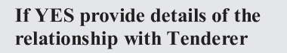
 | 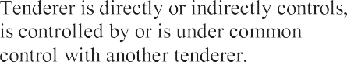
 | 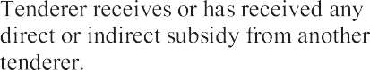
 | 
 | 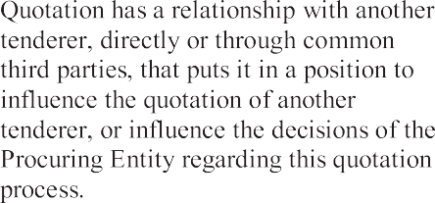
 | 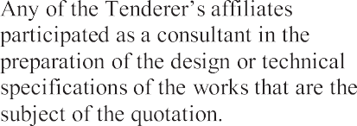
 | 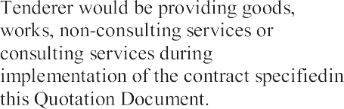
 | 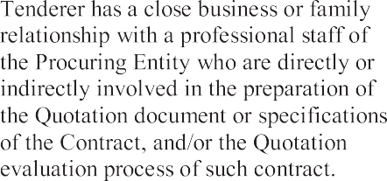
 | 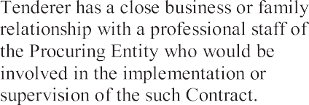
 | 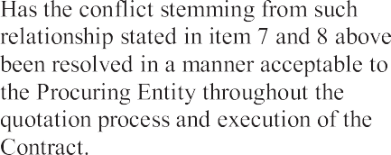

Certiﬁcation
On behalf of the Tenderer, I certify that the information given above is complete, current and accurate as at the date of submission.
Full Name Title or Designation

(Signature) (Date)
Telephone/Mobile number

Email address………………………………………………….

